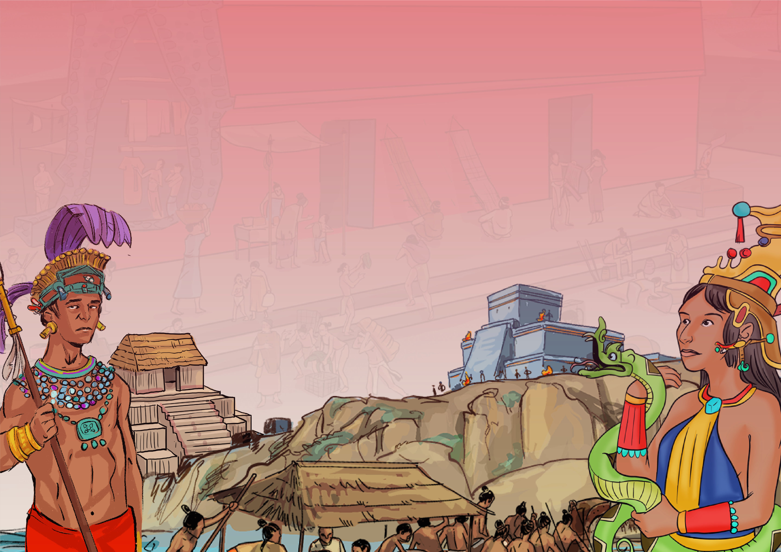



www.grammarsaurus.co.uk

**How do we know about the Ancient Maya?**

**The Ancient Maya Civilisation**

**Maya**

**The Ancient Maya Civilisation**

**1500 CE**

**250 CE**

**950 CE**

**2000 BCE**

**8000 BCE**

**11,000 BCE**

**Paleoindian**

**The first Temple of Kukulkan Chichen Itza started.**

**Calendar**

**Writing**

**Pitz or Pok ta Pok (Maya ball game)**

**Domestication of corn**

**550 CE – 1100 CE**

**250 BCE**

**300 BCE**

**1000 BCE**

**3000 BCE**

**Classic**

**Post Classic**

**Preclassic**

**Archaic**

**Maya**

We know about the Maya because **archaeologists have found evidence of their existence.** The Maya were famous for their **wall art and beautiful writing.** Many examples have been discovered over the years, and these two records give us an idea of what life was like for the different people in Maya society. There have also been many other archaeological discoveries of **Maya tombs, funeral masks, architectural remains of the large city-states, and the famous stone pyramids** that still stand today. There is one mystery that still puzzles archaeologists today. Something strange began to happen in the

**10th century** – the **Maya people** of the central

Maya Lowlands **began to abandon their cities.**

There is **no real evidence** to tell us why just

**multiple theories.**

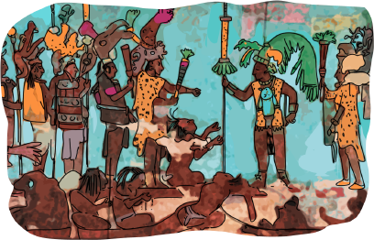

**How do we know about the Ancient Maya?**

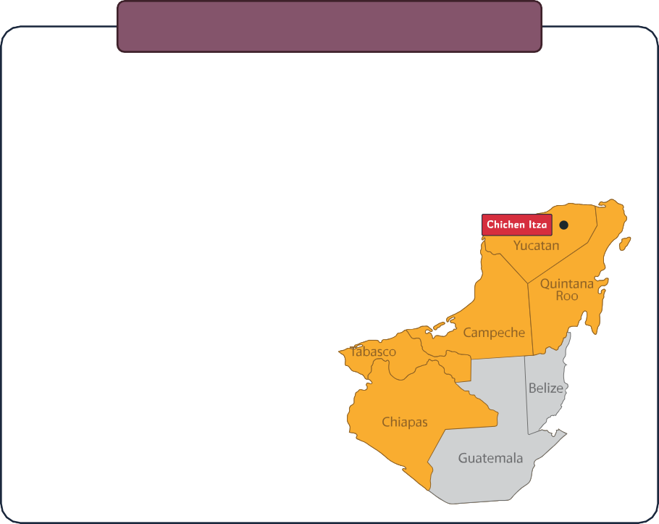

**The Ancient Maya Civilisation**

People have lived in this region for over **12,000 years,** and when they settled here first, **they were hunter-gatherers.** This means they migrated across the land, **searching for food and places to settle.** Over time, these people learned to farm and settled in small villages. Eventually, these   
grew into **large city-states** spread across   
what would one day become **Mexico,   
Guatemala, Belize,** **El Salvador   
and Honduras.** These people   
were called the **Maya,** and their   
power and might reached their   
height in the **10th century.**

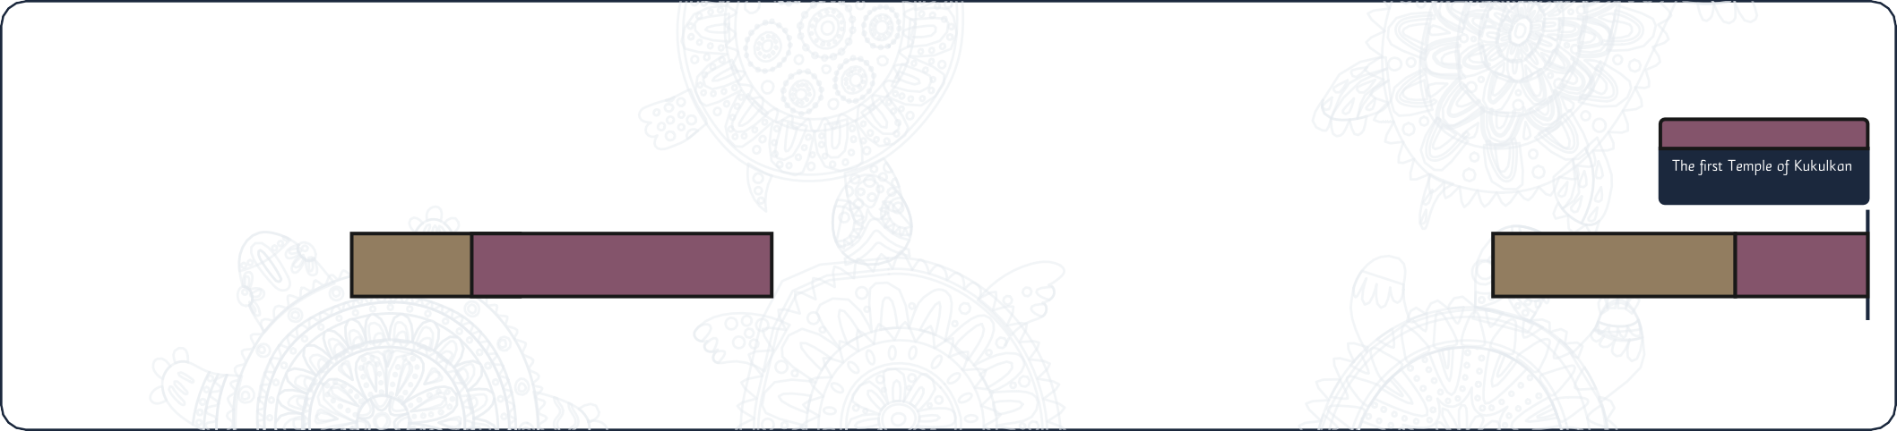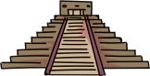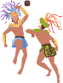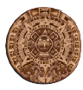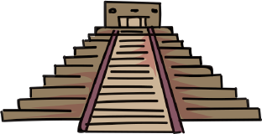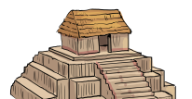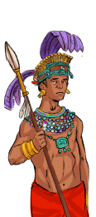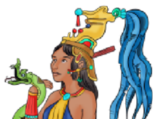



Over time, the city’s population grew, and **the Maya built temples, ballcourts and plazas**. These were **attractive places to live and work** and provided a place for the Maya people to **worship their gods.**

**obsidian**

**limestone**

Instead, **each city was a state** with **its own ruler** and council of high priests.

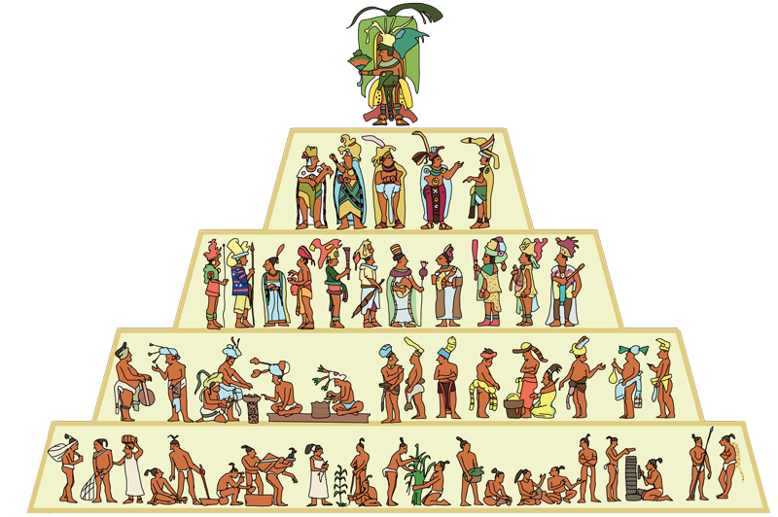

The Maya **were not a united empire** of people with a capital city like **Ancient Egypt.**

The city-states of the Maya often **went to war with each other** to prove that they were **the strongest in the region.**

**Artefacts** show historians and archaeologists that life was **very different for the rich and poor in Maya society.**

**Nobles**

**Council (Priesthood)**

**Commoners - Farmers**

**(and Slaves)**

**Merchants and Artisans**

**King or High Priest (ajaw)**

**Who ruled the Maya people?**



www.grammarsaurus.co.uk

The Maya civilisation grew with

a plentiful supply of **water, specialist farming techniques, and abundant natural limestone and obsidian** for building materials and tools.

**Farming was important for the Maya people.** It was one of the main reasons that the civilisation grew and **became so powerful.** They developed many specialist **farming techniques** to help grow crops and invented a way of **collection and storing water** to irrigate their crops.

**obsidian – a volcanic glass the Maya could sharpen to use as a tool.**

The Maya lowlands were also filed **with limestone – a perfect building material.** They also had access to plenty of

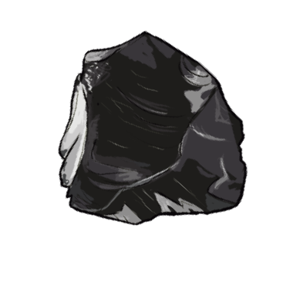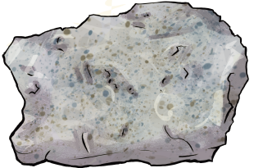

**Who ruled the Maya people?**

**How did the Maya civilisation become successful?**

