

Let the fun continue!

September 2024

This term we will continue to build upon the children's skills and interests. As before, if you have any concerns or questions throughout the year then do not hesitate to talk to us on the gate or put a message in the green contact book.



**Our topic this term – Celebrations**

This half term we will focus on understanding different worldly celebrations. There will be a focus on respecting the traditions of different cultures and understanding the celebrations which their families participate in. To support this topic, please can you send pictures of any celebrations your child has been a part of. This may include a wedding, carnival, christening, christmas or firework night.

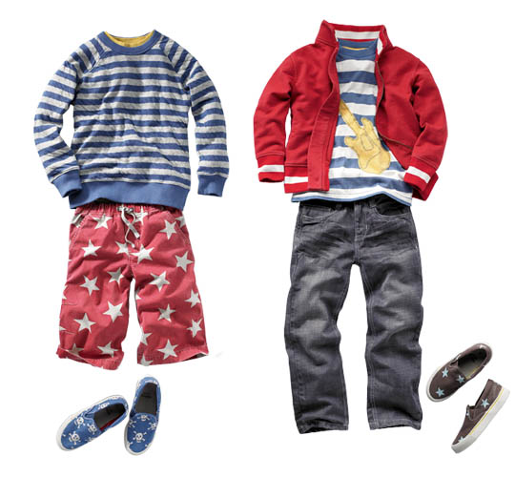

**Outdoor curriculum** Please continue to ensure your child has weather proof clothing and footwear in school every day to facilitate learning in all weather.

We love to get messy and as such accidents may happen. Please bring in a spare set of **named** clothes in a draw string or carrier bag so that we can change your child’s clothes if necessary.

In maths this term, we are learning to count one more and one less as well as composing numbers to 5. We will also be looking at recognising and comparing 2D shapes.

To support your child at home, please continue to recognise numbers and patterns in everyday objects and tasks. Say what you see. As we re deepening our understanding of numbers to 5 this term any support to recognise and begin forming their numerals will boost their confidence.

Continue to read to your child and discuss books every day. Record this in their reading record.

2 books will be sent home on **Friday** each week and should be returned on the following **Thursday**.

Please pay particular attention to helping your child to blend known sounds together to form words.

Please see the little wandle website for support with the current sounds we are covering and how we teach blending.

[www.littlewandlelettersandsounds.org.uk/resources/for-parents/](http://www.littlewandlelettersandsounds.org.uk/resources/for-parents/)



**Key Dates:**

11.11.24 School photos

15.11.24 Children in need

21.11.24 Parents evening

12.12.24 Christmas jumper day

18.12.24 Nativity

18.12.24 Christmas church service



Continue to post photos of your completed homework on google classrooms or bring it in to earn house points.

Our christian value this term is **love**.

Our PE days are Tuesday and Friday. Please send your child to school in their PE kit on both of those days.